OFFLINE SIGNATURE VERIFICATION METHOD BASED ON MATLAB REPRESENTATION
K.Tamilarasi ¹, Dr.S.Nithya kalyani ², D.Abirami ³, R.Sakthi Rekha ⁴, T.Dhanalakshmi ⁵

1. Assistant Professor, Department of ECE, Excel Engineering College,Namakkal.
2.Associate Professor,Department of CSE, K.S.R.College of Engineering, Namakkal.
3,4,5.UG Students, Department of ECE, Excel Engineering College, Namakkal.

Abstract
In an off-line signature verification method based on an matfile representation and a fuzzy similarity measure is proposed. In the feature extraction step, set of grey level co-occurrence matrix (GLCM) based features is computed from both the signature image and its under-sampled bitmap. Mat file is then created for each feature in every signature class. As a result, a signature model composed of a set of values is obtained for each individual’s handwritten signature class. A novel fuzzy similarity measure is future proposed to compute the similarities of samples.
Key words - GLCM, Fuzzy similarity measure, under sampled bit map.
I. INTRODUCTION
Signature is one of the most popular and legally accepted biometrics used in person identification . signature is an important part of human life. Several task need a signature to be completed ,especially for personal authentication and verification. Signatures as one of the behavioural human characteristics, are extensively used as a proof of identity for real purpose on many documents such as bank checks, credit cards, and wills in our daily lives[11,14]. Signature is sign as a symbol of the name written by the hand and by the person himself as a personal marker. Signature is often used in data verification either in schools colleges hospitals government and much more.A signature is a simple, concrete expression of the multiple variation in human hand geometry. The way a person signs his or her name is known to be characteristics of that individual. Signature are learnt and acquired over a period of time rather than being a physiological characteristic, and are influenced by the physical and emotional onditional of a subject.An offline signature consist of some specific characteristics of any individual which
need to be verified for forgery detection. But before that the signature must have gone through some Preliminary steps like pre-processing, feature extraction and computation steps.
II. Preprocessing method
Preprocessing is a common name for operation with images at lowest level of abstraction both input and output or intensity images. The aim of preprocessing is a improvement of image data that supress unwanted distortion or enhance some image features important for further processing. Based on the pixel size we classify four steps,
- Pixel brightness transformation
- Geometric transformation
- Preprocessing methods that use a local neighbourhood of processed pixel
- Image restoration that requires knowledge about the entire image.
III. Feature extraction
The main of feature extraction is to extract the feature from the texture image. In the feature extraction stage the texture-based features are considered for feature extraction. Texture features, such as the Local Binary Pattern (LBP), the Local Derivative Pattern (LDP), and Grey Level Co-occurrence Matrix (GLCM), have widely been employed in different biometric systems including signature verification and some promising results have also been provided[16,17].
The Notable results obtained in signature verification using the texture features, especially the LBP-based features, are due to the exceptional properties of the LBP-based features, which can provide important information about the personal characteristics of a signer including such elements as the amount of pressure and speed changes, pen-holding, ink distribution[18].
IV. PROPOSED METHOD
For proposed system, in preprocessig method we use filterization and binarization process. In that, median filter is used to filter the salt and pepper noise and detect the edges. Binarization is used for enhance the signature image. In feature extraction method we use GLCM algorithm. The GLCM (Gray level co-occurrence matrix) is used to extract the texture features in the image.
13
Different signature Image (Testing)

Pre-Processing

Feature extraction

Mat file creation model for each individual

Knowledge-based signature models
Computation of similarity values

Making the decision on test signature

Fig a. An overview of proposed method

The overview of proposed method(Fig a) is explained as follows,
A. Preprocessing:
we take a different types of signature image as input in that we take any one of signature as testing sample in that, we done a filtering process by using a median filter which is used to remove noise then we done a binarization process which is used to enhance the signature image by eliminating the background of the signature image.
The median filter is a nonlinear filter digital filtering technique, often used to remove noise from an image or signal. such noise reduction is a typical pre-processing step to improve the results of later processing. Median filter is very widely used in digital image processing .because, median filter is one kind of smoothening technique, as is linear Gaussian filtering. All smoothening techniques are effective at removing noise in smooth patches or smooth regions of a signal, but adversely affect edges. Under-sampled bitmap images have been used in the literature for pattern recognition [8]. Often though, at the same time as reducing the noise in a signal, it is important to preserve the edges. edges are critical importance to the visual appearance of image, for example for small to moderate levels of (Gaussian) noise, the median filter is demonstrably better than Gaussian blur at removing noise whilst preserving edges for a given, fixed window size. However its performance is not that much better than Gaussian blur for high levels of noise, whereas, for speckle noise and salt and pepper noise, it is particularly effective. Because of this, median filtering is very widely used in digital image processing.

B. Feature extraction
In statistical texture analysis, texture features are computed from the statistical distribution of observed combinations of intensities at specified positions relative to each other in the image[18]. According to the number of intensity points (pixels) in each combination, statistics are classified into first-order, second order and higher-order statistics.
The Gray Level Co-occurrence Matrix (GLCM) method is a way of extracting second order statistical texture features. The approach has been used in a number of applications, Third and higher order textures consider the relationships among three or more pixels. These are theoretically possible but not commonly implemented due to calculation time and interpretation difficulty.
A GLCM is a matrix where the number of rows and columns is equal to the number of gray levels, G, in the image. The matrix element P (i, j | ∆x, ∆y) is the relative frequency with which two pixels, separated by a pixel distance (∆x, ∆y), occur within a given neighbourhood, one with intensity ‘i’ and the other with intensity ‘j’. The matrix element P (i, j | d, ө) contains the second order statistical probability values for changes between gray levels ‘i’ and ‘j’ at a particular displacement distance d and at a particular angle (ө). Using a large number of intensity levels G implies storing a lot of temporary data, i.e. a G × G matrix for each combination of (∆x, ∆y) or (d, ө). Due to their large dimensionality, the GLCM’s are very sensitive to the size of the texture samples on which they are estimated. Thus, the number of gray levels is often reduced. GLCM matrix formulation for four different gray levels. Here one pixel offset is used (a reference pixel and its immediate neighbour). If the window is large enough, using a larger offset is possible.
C. Creation and Verification Process:
The data fusion value is stored in a database that database is found by using a knowledge based signature models. Then the testing samples follow the same procedure till the feature extraction. The testing sample finally compute by using fuzzy similarity method[13,14]. Then the computation result is come under the decision making part[20,21].

IV. RESULT

1. Input image:



Fig.1. Input image of signature. Example image is given as input in fig.1.

2. Median filter image:

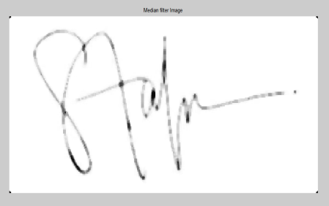

Fig.2. Median filter image. The median filter image of given signature (fig 1)is shown in fig.2. In that salt and pepper noises are removed in the figure2.

3. Binary image:

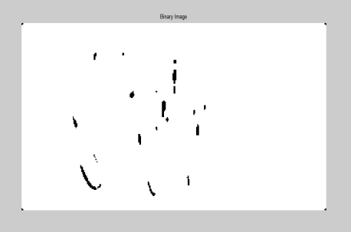

Fig. 3. Binary image. The binary image of the given signature as shown in fig 3. After the completion of filtering and binarization process.

4. Under sampled image:

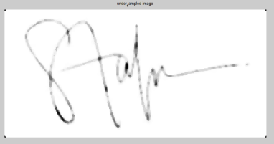

Fig. 4. Under sampled image. The under sample image of the given signature is shown in fig 4. Which is used for avoiding mixing of samples[8].

5. Feature extracted image:



Fig. 5. Feature extracted image. The feature extracted image of the given signature is shown in fig 5. In that the texture features of image is extracted[18].

6. Sketch of image:

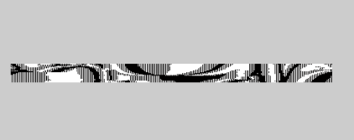

Fig. 6. sketch of image. The sketch of given signature is shown in fig 6.

7. Fuzzy segmented image:



Fig. 7. Fuzzy segmented image. The fuzzy segmented image is shown in fig 7. This figure shows the comparative analysis of signature[20,21].

8. Genuine representation
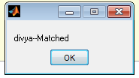

Fig. 8. Genuine representation. The genuine representation of Signature is shown in fig 8.

9. Forgery representation



Fig. 9. Forgery representation. The forgery representation of signature is shown in fig 9.

V. Conclusion
In this investigation, the performance of proposed matfile representation model for offline signature verification is demonstrated. A fuzzy similarity measure is applicable to address the inter class variability of features. The proposed method provide significantly improved result compare to the state of art methods. The main advantage of proposed model is Offline signature verification has several advantages over its on-line counterpart. Firstly, it has widely been accepted in the society. It is more convenient as it does not require any special instruments. The large amount of bank checks, credit card authentication forms, or legal documents still being signed every day, offline verification has considered commercial potential.
VI. REFERENCES
[1] Javier Ruiz-del-solar, ChristDevia, and PatricoLoncomilla, ad Felipe Concha “Offline signature verification using local interest points and descriptors”, in pp. 22-29,2008.
[2] Vu Nguyen, Yumiko Kawazoe, Tetsushi Wakabayashi, Umapada Pal, and Michael Blumenstein, “Performance analysis of the gradient feature and the modified direction feature for off-line signature verification” in pp.303-307, 2010.
[3] SrikantaPal, Umapada Pal, and Michael Blumenstein “A Two-stage approach for english and hindi offline signature verification” in pp.140-148,2013.
[4] Meenakshi K.Kalera, Sargursrihari and Aihuaxu,”Offline signature verification and identification using distance statistics” in international journal of pattern recognition and artificial inteligence, in vol.18, no.7 pp.1339-1360,2004
[5] Bo Xu, Daozhi Lin, Longbiao Wang, Hongyang Chao, Weifeng Li and QinminLiao, ”Performance comparison of local directional pattern to local binary pattern in offline signature verification system” in pp.308-312, 2014 .
[6] Donato Impedovo and Giuseppe Pirlo, ”Automatic signature Verification: The state of the art” in IEEE transaction on systems man, and cybernetics-part c: Application and reviews, in vol.38, pp.609-628, 2008.
[7] Muhammad Imran Malik, Marcus Liwicki, Linda Alewijnse, WataruOhyama, Michael Blumenstein, Bryan Found,”ICDAR2013 Competition on signature verification and writer identification for on and offline skilled forgeries(SigWiComp2013)” in pp.1478-1483, 2013.
[8] Garris, M. D. et al., “NIST Form-Based Handprint Recognition System”, NISTIR 5469, 1994.
[9] R.Plamondon and G.Lorette, “Automatic signature verification and writer identification- the state of the art,” Pattern recognition, vol.22, pp.107-131,1989.
[10] Xinghua Xia, XiaoyuSong, Fangun Luan, Jungangzheng, zhilichen, xizofu Ma,” Discriminative feature selection for on-line signature verification” in vol 74,pp 422-433,2017.
[11] Ruben Tolosana, Ruben Vera-Rodriguez, Javier Ortega-Garcia, and Julian Fierrez, ”Preprocessing and feature selection for improved sensor interoperability in online biometric signature verification” in vol 3, pp478-489,2015
[12] D. Impedovo G. Pirlo, “ Automatic signature verification: The state of Art”, IEEE Transactions on systems, Man and Cybernetics –Part c: Application and Reviews, pp. 609-635, 2008.
[13] C. Simon, E. Levrat, J. Bremont, R. Sabourin, “A fuzzy perception for off-line handwritten signature verification”, BSDIA'97, pp. 261-272, 1997.
[14] V. K. Madasu, M. H. M. Yusof, M. Hanmandlu, K. Kubik, “Off-line signature verification and forgery detection system based on fuzzy modeling”, Advances in Artificial Intelligence volume: 2903, edited T. D. Gedeon, and L.C.C Fung, pp.1003-1013, 2003.
[15] M. Hanmandlu, M. H. M. Yusof, V. K. Madasu, “Off-line signature verification and forgery detection using fuzzy modeling”, Pattern Recognition”, 38(3), pp. 341-356, 2005.
[16] Y. W. Woo, S. Han, K. S. Jang, “Off-Line Signature Verification Based on Directional Gradient Spectrum and a Fuzzy Classifier”, in Proc. of the First Pacific Rim Symposium (PSIVT 2006), pp. 1018-1029, 2006.

[17] D. Impedovo, G. Pirlo, M. Russo, “Recent Advances in Offline Signature Identification”, In Proc. of the 14th International Conference on Frontiers in Handwriting Recognition, pp. 639-642, 2014.
[18] L. G. Hafemann, R. Sabourin, L. S. Oliveira, “Offline Handwritten Signature Verification - Literature Review”, pp. 1-15, 2015. http://dblp.uni-trier.de/db/journals/corr/corr1507.html#HafemannSO15.
[19] F. Leclerc and R. Plamondon, “Automatic signature verification: the state of the art-1989-1993”, Intl. Journal of Pattern Recognition and Artificial Intelligence, 8(3), pp. 643–660, 1994.
[20] R. Plamondon and S. N Srihari, “Online and off-line handwriting recognition: a comprehensive survey”, IEEE Transactions on Pattern Analysis and Machine Intelligence, 22(1), pp. 63–84, 2000.
[21] B. Xu, D. Lin, L. Wang, H. Chao, W. Li and Q. Liao, “Performance comparison of local directional pattern to local binary pattern in off-line signature verification system”, International Congress on Image and Signal Processing, pp. 308-312, 2014.
[22] S. Marcel, Y. Rodriguez, G. Heusch, “On the recent use of local binary patterns for face authentication”, International Journal on Image and Video Processing, Special Issue on Facial Image Processing, IDIAP-RR 06-34, 2007.
[23] J. F. Vargas, M. A. Ferrer, C. M. Travieso, and J. B. Alonso, “Off-line signature verification based on grey level information using texture features”, Pattern Recognition, 44(2), pp. 375–385, 2011.

